Nested try, except , finally
Try , except , finally can be used inside try block, except block as well as finally block
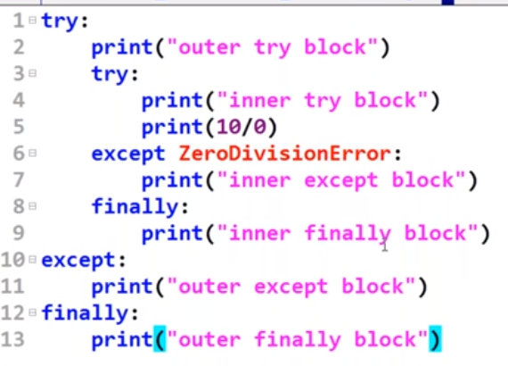
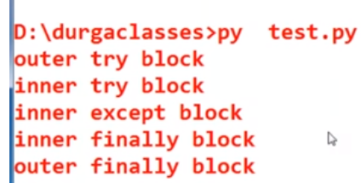
Finally always gets executed no matter except is executed or not
Diff between else and finally
Else block will be executed only if try block executed normally
Finally always executed no matter try block executed normally or not

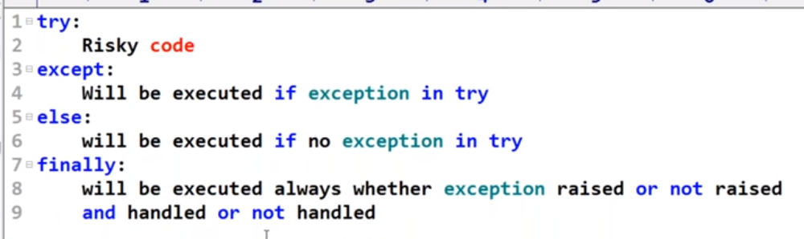

Various possible combination of try, except, else, finally

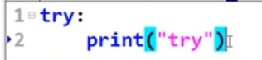------invalid

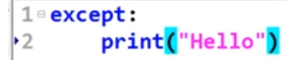------invalid

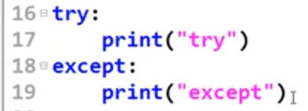---valid

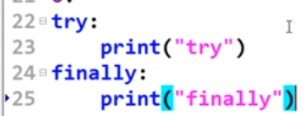----valid, abnormal termination will be printed after finally

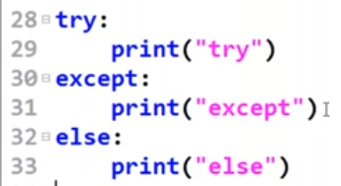-----valid

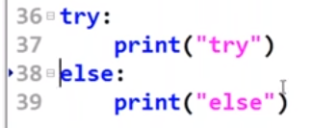-----invalid

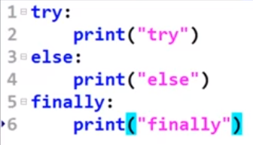-----invalid

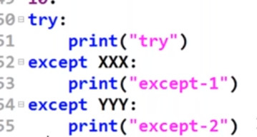-----valid

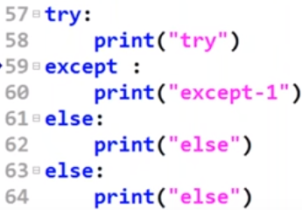-----invalid

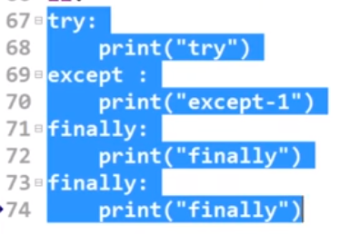------invalid

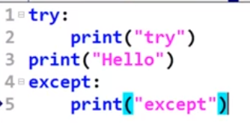----invalid, try and except separated because of print

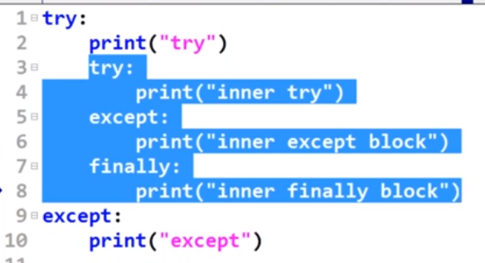------valid

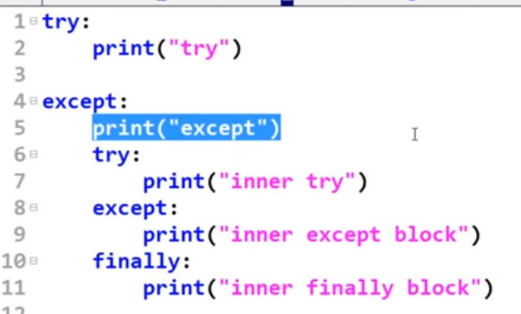------valid

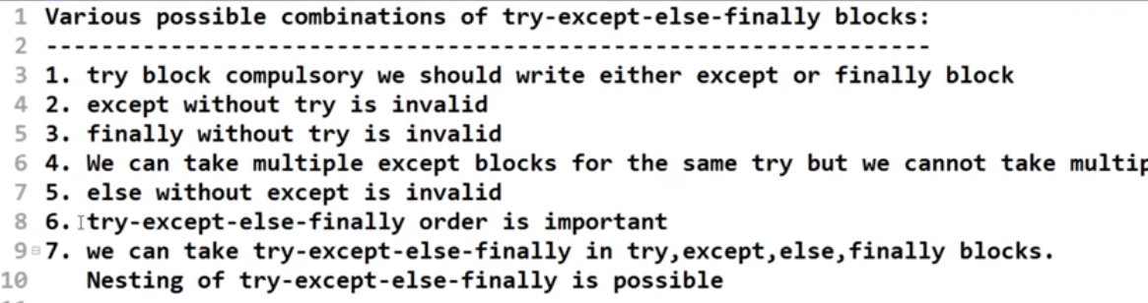

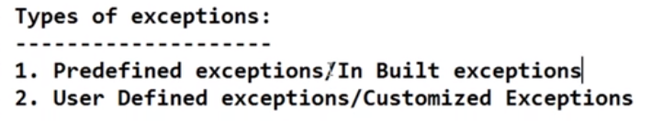
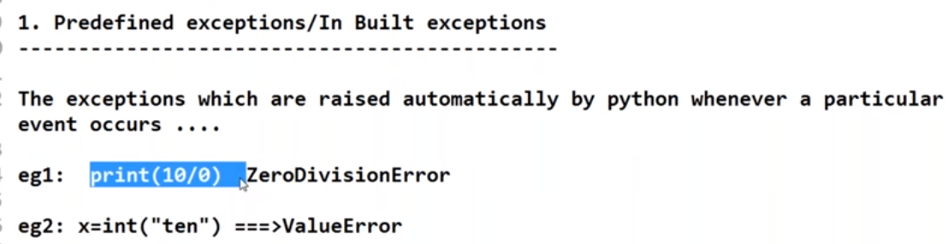

02. User defined exception
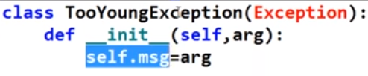
Exception is in built class and TooYoungException is extending the class
Def__init__(self,arg)-----is constructor, self is like this in java

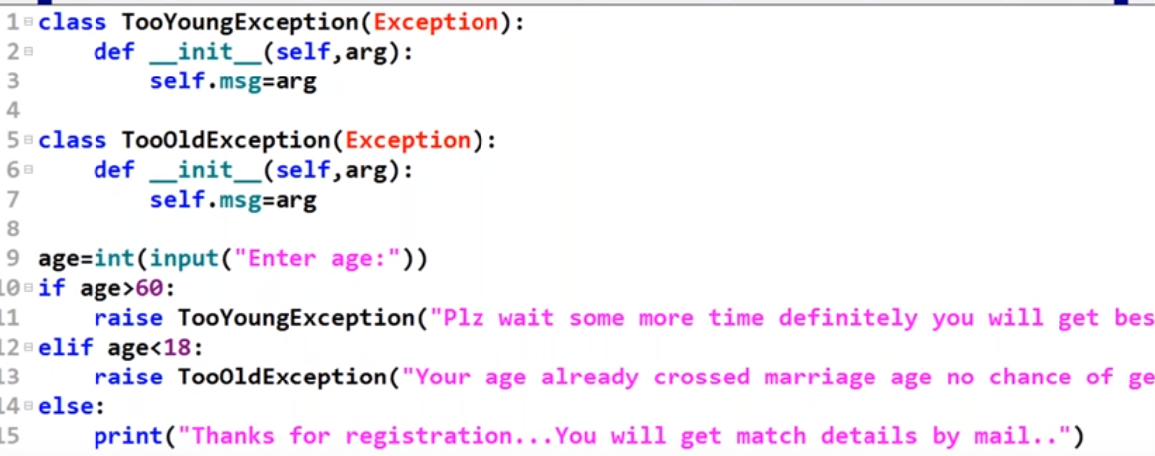

Logging and Debugging

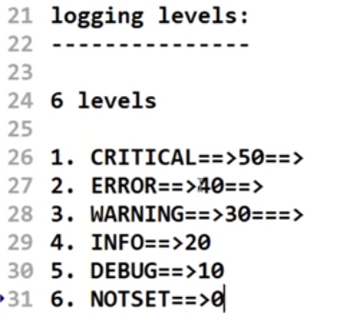

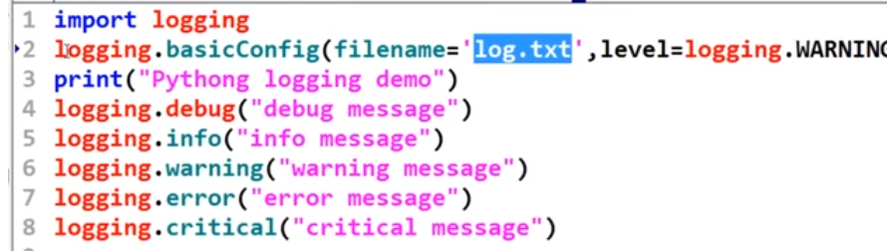

Instead of logging.warning if we use logging.DEBUG will log everything

logging.warning willonly log last three

Class

Create class

class MyClass:
x = 5

Create object of class and access the variable

p1 = MyClass()
print(p1.x)

Constructor

class Person:
def __init__(self, name, age): -------this is constructor
self.name = name
self.age = age
p1 = Person("John", 36)
print(p1.name)
print(p1.age)

class Person:
def __init__(self, name, age):
self.name = name
self.age = age
def myfunc(self):
print("Hello my name is " + self.name)
p1 = Person("John", 36)
p1.myfunc()
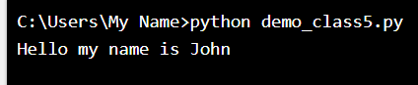

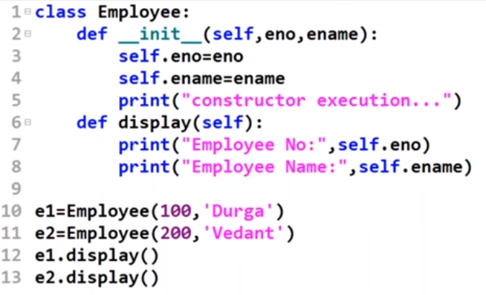

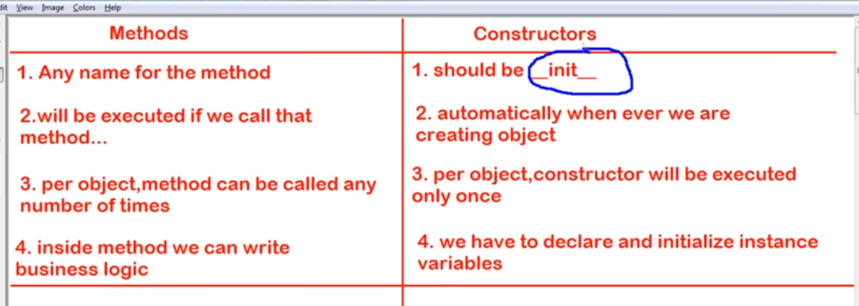

Delete object properties

class Person:
def __init__(self, name, age):
self.name = name
self.age = age

def myfunc(self):
print("Hello my name is " + self.name)

p1 = Person("John", 36)

del p1.age

print(p1.age)-----error

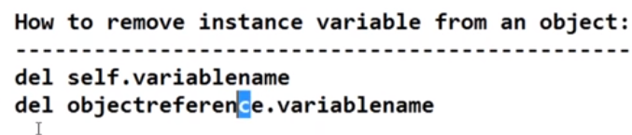

Inheritance

class Person:
def __init__(self, fname, lname):
self.firstname = fname
self.lastname = lname
def printname(self):
print(self.firstname, self.lastname)
#Use the Person class to create an object, and then execute the printname method:
x = Person("John", "Doe")
x.printname()

class Student(Person): -----create child class
pass

x = Student("Mike", "Olsen")
x.printname()

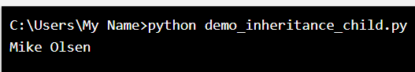

Iterator

Return an iterator from a tuple, and print each value:
mytuple = ("apple", "banana", "cherry")
myit = iter(mytuple)
print(next(myit))
print(next(myit))
print(next(myit))

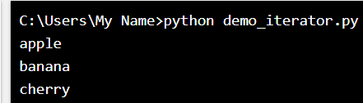

Types of variables

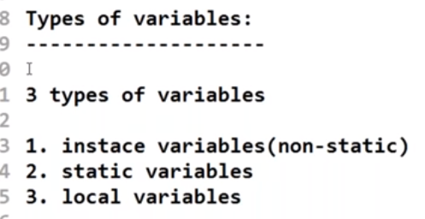
Static variables are also called as class variables

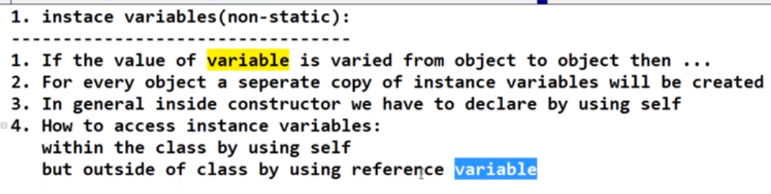

In below example, self.name, self.rollno and self.marks are instance variables

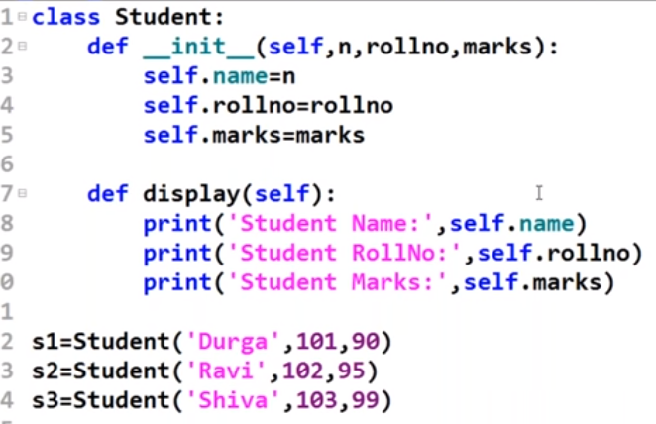

Below line also works

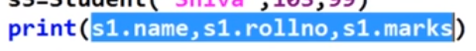

Below line will give object related information in dictionary format

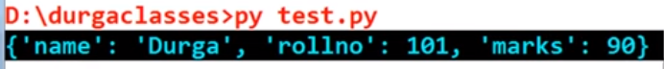

Instance variables can be declared inside method also but they will be activated when the method gets called

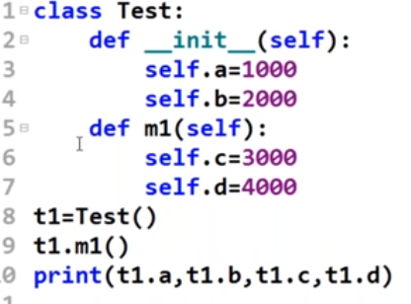

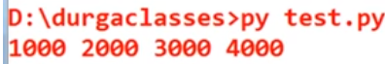

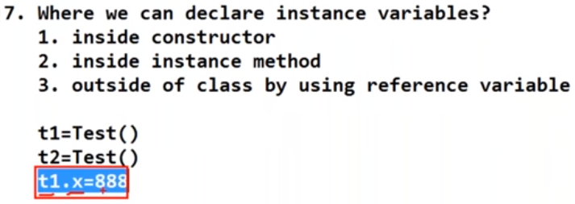

If t1.x is already there then replace the value else create new variable and assign value

Static variable

In below example a is static variable

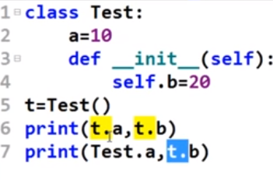

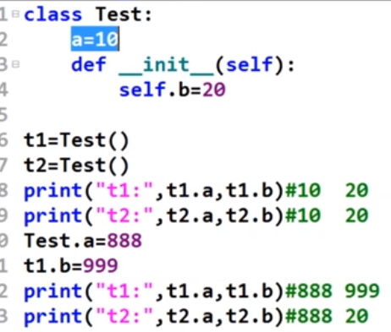

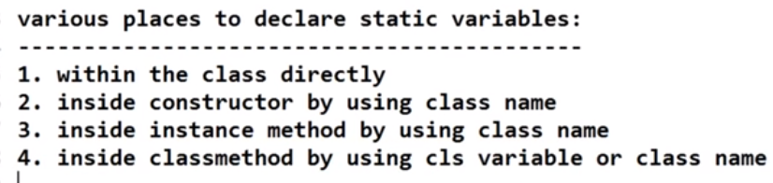

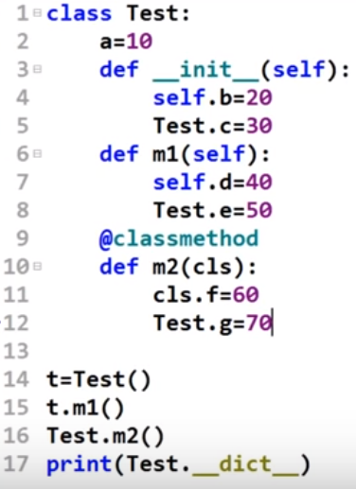

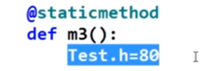



Regular expression

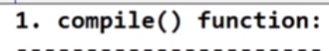
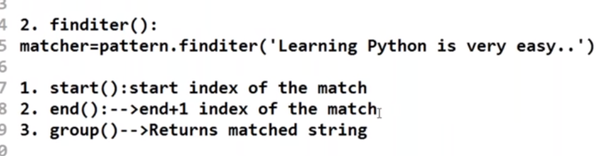

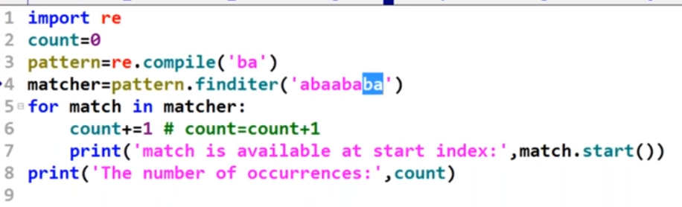

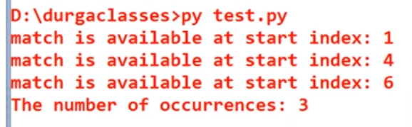

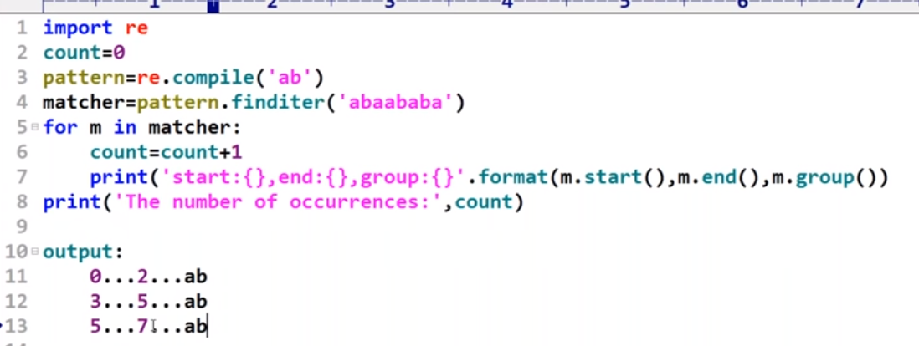

m.start()------gives start index of string we are searching
m.end()------gives end index +1 of the string we are searching
m.group()----gives what string we are searching

below code words in same way

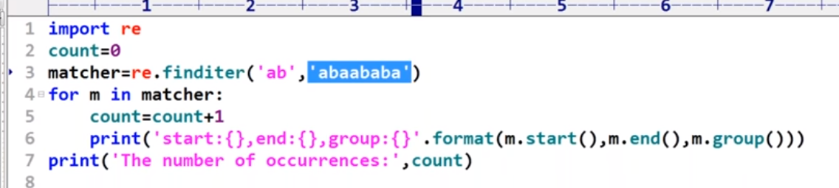

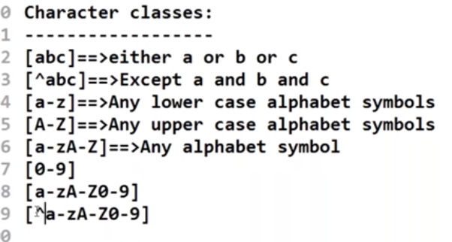

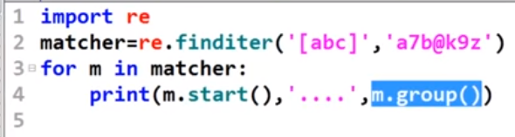

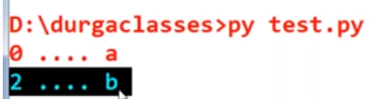

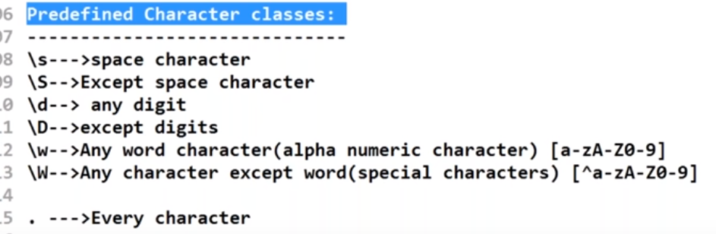

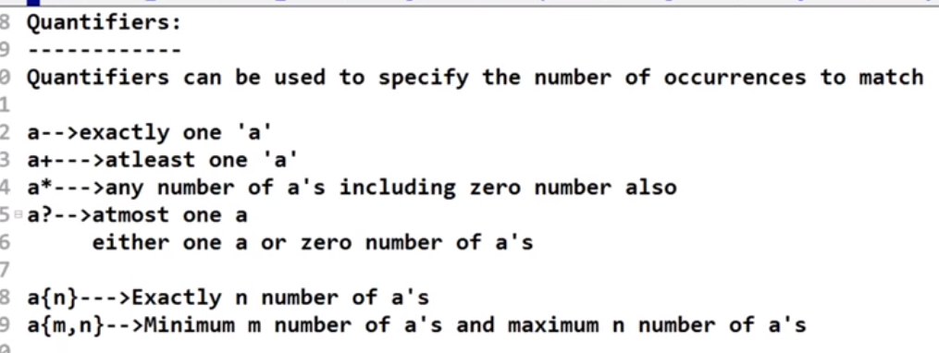

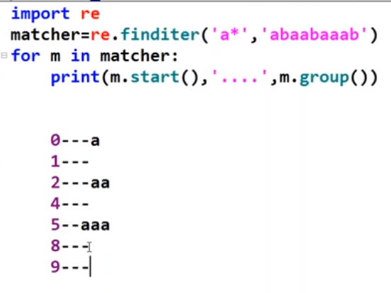

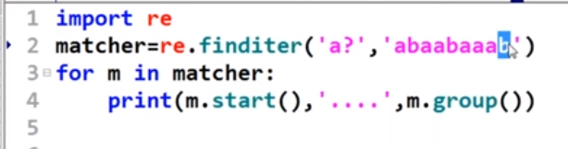

s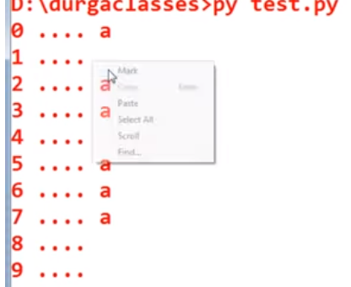

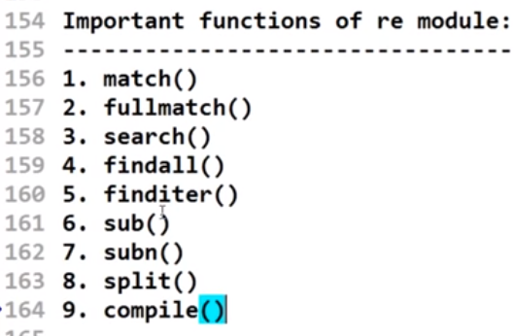

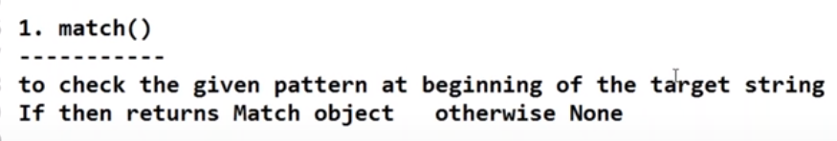

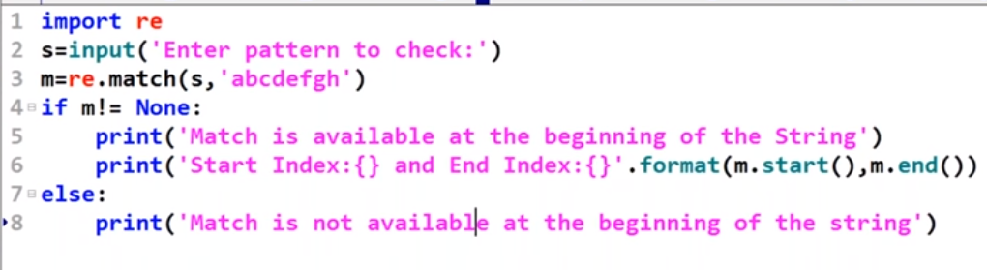

Fullmatch()
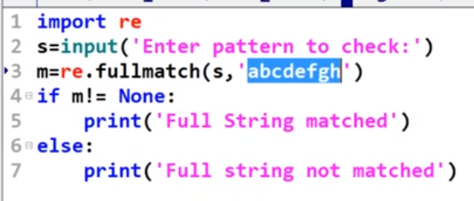

Search()----search the given string in the target string and return first occurance

Findall()

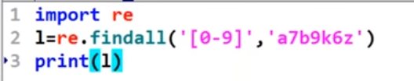
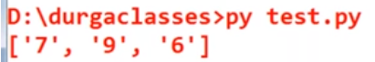

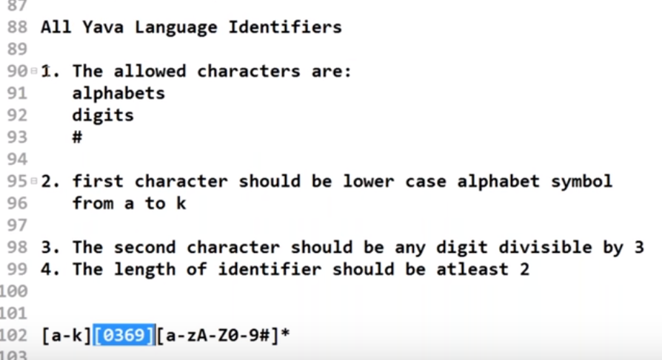

Match mobile number

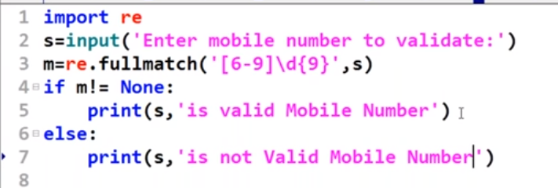

Mail id matching
